Online Purchase Behaviour Classification

Project Id: AIML - 21

Name : Prakash Chandra Pandey
Class Roll Number:61
University Roll Number : 2028799
Section and Group: Q(G2)

Name : Harsh Rastogi
Class Roll Number:46
University Roll Number : 2028722
Section and Group: Q(G2)

Name : Ayush Pundir
Class Roll Number:43
University Roll Number : 2028686
Section and Group: Q(G2)

TABLE OF CONTENTS

- Problem Description 3
- Architecture 4
- Models model 5
- Evaluation metrics used 6
- Preliminary Results and Visualizations 7
- References 8

- Problem Description

In today’s digital era, e-commerce platforms generate a large amount of user interaction data. Understanding customer behavior has become essential for businesses to improve sales, enhance user experience, and design effective marketing strategies. One of the key challenges for online businesses is to predict whether a user visiting a website will make a purchase or not.
Manual analysis of such behavior is difficult due to the high volume and complexity of data. Factors like page visits, time spent on different pages, bounce rate, exit rate, product-related interactions, and user session details all influence purchasing decisions. Analyzing these factors manually can lead to inaccurate conclusions and inefficient decision-making.
To address this problem, this project focuses on building a machine learning-based classification system that predicts online purchase behavior. The system uses a dataset containing various user session attributes and applies data preprocessing, feature selection, and classification algorithms to identify patterns in user behavior.
In Phase 2 of the project, different machine learning models such as Logistic Regression, K-Nearest Neighbors (KNN), Decision Tree, and Support Vector Machine (SVM) are implemented and compared. These models are evaluated using performance metrics like accuracy, precision, recall, and F1-score to determine the most effective approach.
The goal of this project is to develop a reliable and efficient system that can accurately classify whether a user will make a purchase. This can help businesses optimize recommendations, improve targeting strategies, and increase overall conversion rates through data-driven insights

- Architecture

• Data Loading:
The online purchase behavior dataset is imported into the system.

• Data Preprocessing:
The dataset is cleaned by handling missing values , handling outliers , and standardization to make the data suitable for model training.

• Feature Selection:
Important features such as Browsing Time , Number of clicks , Product views ,Cart_Additions are selected to improve accuracy and reduce unnecessary data.

• Data Splitting:
The dataset is divided into 80% training data and 20% testing data.

• Model Training:
• Logistic Regression: Used to classify whether a user will make a purchase or not.
• KNN Classifier: Trained with k = 3 neighbors to classify user behavior.
• Decision Tree Classifier: Trained with controlled depth to avoid overfitting.
• Support Vector Machine (SVM): Used to find the optimal separating boundary.

• Model Prediction:
The trained models predict whether the user will make a purchase (1) or not (0).

• Model Evaluation:
Performance is measured using Accuracy, Precision, Recall, F1-score, and Confusion Matrix.

• Final Output:
The system outputs the predicted result:
- 1 → Purchase
- 0 → No Purchase

- Models Used(Applied/ Planned)

Logistic Regression
Logistic Regression is a supervised machine learning algorithm used for binary classification problems. In this project, it is used to predict whether a user will make a purchase (1) or not (0). It works by applying a sigmoid function to transform the output into a probability value between 0 and 1. If the probability is greater than a threshold (usually 0.5), the user is classified as a buyer. This model is simple, fast, and provides good baseline performance with easy interpretability.

K-Nearest Neighbors (KNN)
KNN is a non-parametric and instance-based learning algorithm. It classifies a data point based on the majority class of its k nearest neighbors in the dataset. In this project, it identifies users with similar behavior patterns and predicts whether they will make a purchase based on nearby users. The value of k (e.g., k=3) plays an important role in performance. KNN works well for pattern recognition but can be computationally expensive for large datasets.

Decision Tree Classifier
Decision Tree is a supervised learning algorithm that splits the dataset into smaller subsets based on feature conditions. It creates a tree-like structure where each node represents a decision rule, and each branch represents an outcome. In this project, it helps in understanding how different features (like time spent, page visits, etc.) affect purchasing decisions. It can handle both linear and non-linear relationships and is easy to interpret, but it may overfit if not properly controlled.

Support Vector Machine (SVM)
SVM is a powerful classification algorithm that finds the optimal hyperplane to separate different classes in the dataset. It tries to maximize the margin between the classes, making it effective even in high-dimensional spaces. In this project, SVM helps in accurately distinguishing between users who will purchase and those who will not. It works well for complex datasets but may require more computation and parameter tuning.

- Evaluation metrics used

Accuracy:
Measures overall correctness of predictions.

Precision:
Indicates how many predicted purchases are actually correct.

Recall:
Measures how many actual purchases are correctly identified.

F1-Score:
Balance between precision and recall.

Confusion Matrix:
Shows classification results in terms of TP, TN, FP, FN.

- Preliminary Results and Visualizations

Based on the execution of phase 2 , the models achieved the following results :

The model was trained using selected features obtained through Sequential Feature Selection (SFS). The most important features identified are:
- Browsing_Time
- Clicks
- Product_Views
- Cart_Additions
These features were found to have a significant impact on the prediction outcome. Using only these relevant features helped in improving model performance and reducing unnecessary complexity.

- Fig.1 Correlation Heatmap
Shows relationship between features affecting purchase behavior.

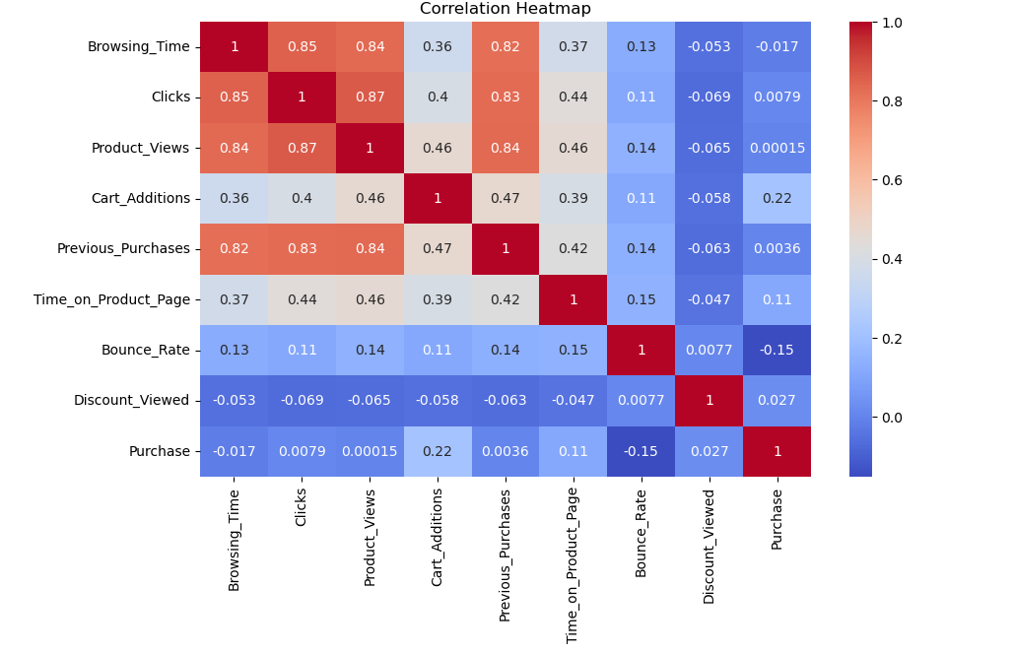
6. References:
Books:
- Let Us Python – Yashavant Kanetkar

Online Resources:
  - GeeksforGeeks – https://www.geeksforgeeks.org/
  - TutorialsPoint – https://www.tutorialspoint.com/cprogramming/index.htm
  - Stack Overflow – https://stackoverflow.com
  - Pandas Documentation – For data preprocessing and dataset handling.
  - NumPy Documentation – For numerical operations and array handling

